Article ID: 1078
Article Name: There is leaking from the inlet hose of my Washer Dryer
Topic Location: Laundry, Washer Dryer, Water, Leakage
Meta-data: Leak, water, hose, tube, flood
Related Articles:
Related Questions:
PNC
DIY
Safety
Link
Email
Book Engineer
Multimedia
Brand
Article Content:
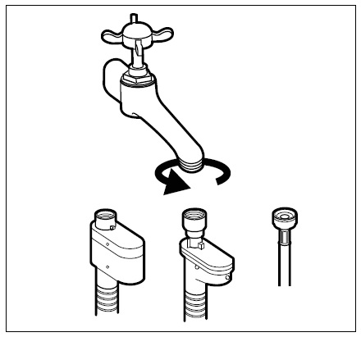
To solve the problem please check the following:
- The inlet tube connector to the wall inlet or water tap. Check that the connector is correctly screwed and pressed. Do not use pliers or similar to press the connector, it should only be pressed by hand!
- Check that there is no leak from the inlet water tap. If you find that there is a leak coming from the tap you should call a plumber to solve the problem.

Picture: 1078_01_There is leaking from the inlet hose of my Washer Dryer-JAT-13-11-27
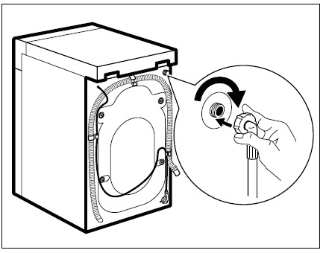
- Check the water connector to the inlet of the machine. The connector should be correctly screwed and pressed. Do not use pliers or similar to press the connector, it should only be pressed by hand!
IMPORTAN! If you observe that the tube is damaged (split or cracked), you should cut the water supply to the machine and get in touch with our Technical Service to order a new part. Please contact us dialling: [profile for Spain] 902 116 388.
Picture: 1078_02_There is leaking from the inlet hose of my Washer Dryer-JAT-13-11-27

